Links
http://www.journalism.org/2010/05/23/new-media-old-media/

5 Differences Between new and old media
http://www.huffingtonpost.com/sachin-kamdar/5-differences-between-old_b_9670634.html

What is new media? Old Media? Effects?
https://www.absolutemg.com/2014/12/23/traditional-media-balancing-effect/
http://larunadhir.blogspot.co.at/2011/12/old-vs-new-in-media-melange.html

Advantages and disadvantages
https://pt.slideshare.net/HeatherCherry/new-media-vs-old-media-10562515?ref=&smtNoRedir=1

Fake News
https://www.forbes.com/forbes/welcome/?toURL=https://www.forbes.com/sites/thomasbasile/2016/12/12/the-real-fake-news-is-the-mainstream-media/&refURL=https://www.google.at/&referrer=https://www.google.at/

Bilder
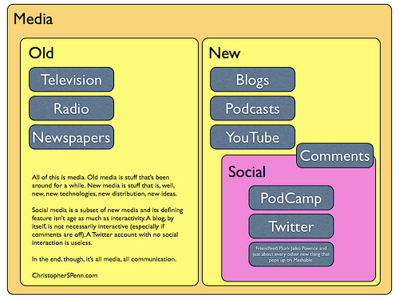
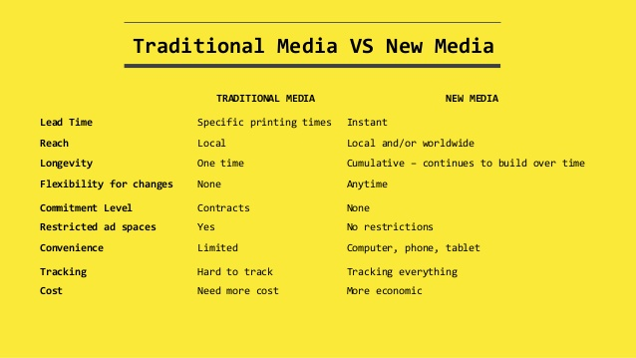

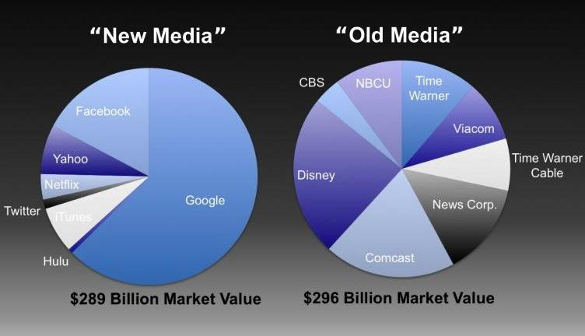
date above: 2012
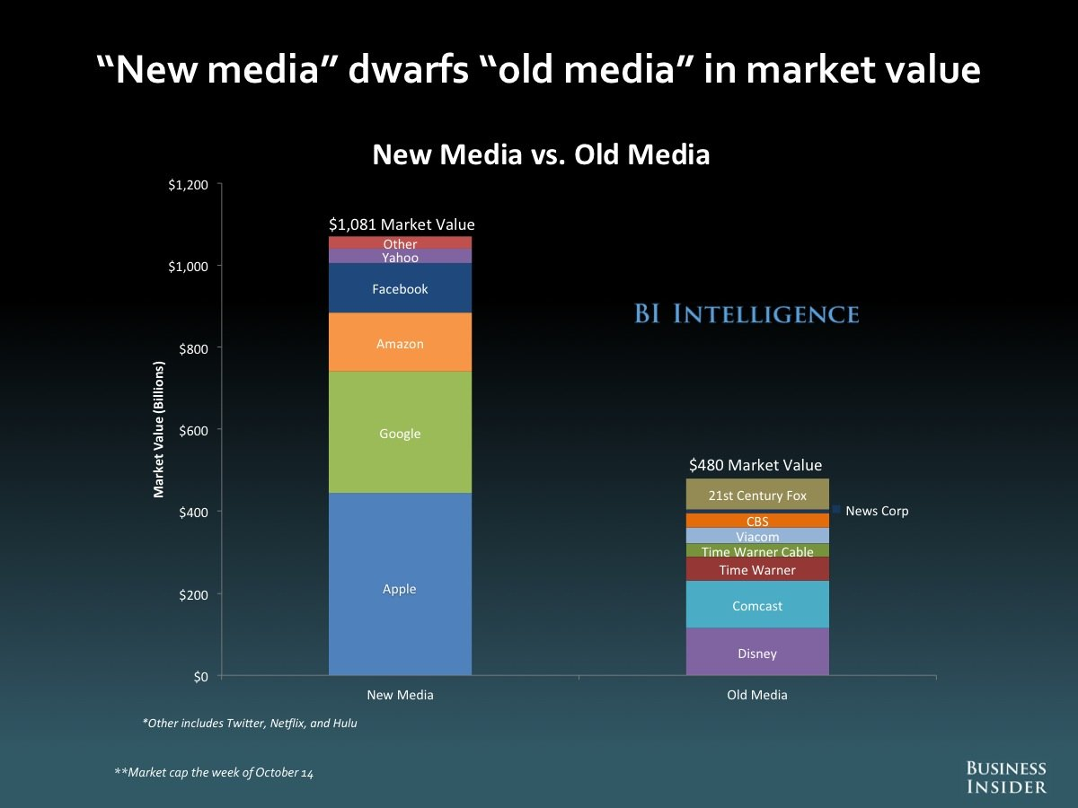
date above: 2014

